American GI Forum Education Foundation
of Santa Maria, CA

702 E. El Camino Street, Santa Maria, CA 93454
(805) 478-6230
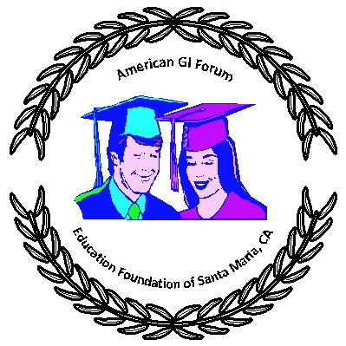

2024 SCHOLARSHIP APPLICATION
Personal Information:
Name: |  | Age:
Address: |  | Phone:
City/Zip: | Email:

Name of Parent(s): | Phone:

Educational Information:
Presently Enrolled at: | GPA:

Current Grade/Year in School: | Expected Year of Graduation:

College/University you Plan to Attend in 2023-24:

Major/Minor Field of Study:

THE FOLLOWING CRITERIA WILL BE USED TO DETERMINE ELIGIBILITY:
A. Completely fill out this application.
B. One page statement (150-200 words) regarding your educational goal.
C. One letter from a teacher, counselor, or employer who knows you well.
D. Your college or high school transcript (most current – need not be sealed).
E. Mail this application and items B, C and D to:
American GI Forum Education Foundation
702 E. El Camino Street
Santa Maria, CA 93454
OR: Email to: helen.galvan@gmail.com

This application must be received by June 8, 2024
No applications will be accepted after this date.

“Education is Our Freedom, and Freedom Should Be Everybody’s Business”

